**Assignment--Normalization**

A company called FastCabs provides a taxi service to clients. The table shown in Figure 1 displays some details of client bookings for taxis. Assume that a taxi driver is assigned to a single taxi but a taxi can be assigned to one or more drivers.

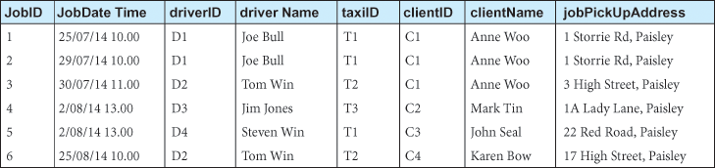

Figure 1: Table displaying sample data for FastCabs

1. Identify the functional dependencies that exist between the columns of the table.
   1. JobID -> JobDateTime, driverID, driverName, taxiID, ClentID, clentName, jobPickupAddress
   2. driverID -> driverName, taxiID
   3. clientID ->clientName
2. Identify the primary key.
   1. JobID is the primary key
3. Determine the Normal Form of the table based on the primary key you identified.
   1. Since there are no duplicate records, this passes 1NF.  
      Since partial dependency exists, this fails 2NF.  
      Since 2NF fails, so does 3NF.
4. Normalize the table to 3NF. You should give the explanation when you decompose a table.

|  |  |  |  |  |
| --- | --- | --- | --- | --- |
| **JobID** | **JobDateTime** | **driverID** | **ClientID** | **jobPickUpAddress** |
| 1 | 25/07/14 10:00 | D1 | C1 | 1 Storrie Rd, Paisley |
| 2 | 29/07/14 10:00 | D1 | C1 | 1 Storrie Rd, Paisley |
| 3 | 30/07/14 11:00 | D2 | C1 | 3 High St, Paisley |
| 4 | 2/08/14 13:00 | D3 | C2 | 1A Lady Lane, Paisely |
| 5 | 2/08/14 13:00 | D4 | C3 | 22 Red Rd, Paisley |
| 6 | 25/08/14 10:00 | D2 | C4 | 17 High St, Paisely |

|  |  |  |
| --- | --- | --- |
| **driverID** | **driverName** | **taxiID** |
| D1 | Joe Bull | T1 |
| D2 | Tom Win | T2 |
| D3 | Jim Jones | T3 |
| D4 | Steven Win | T1 |

|  |  |
| --- | --- |
| **clientID** | **clientName** |
| C1 | Anne Woo |
| C2 | Mark Tin |
| C3 | John Scal |
| C4 | Karen Bow |